Melody Wheelwright
Joshua Braegger
CS 3750 – Grayston
Use Case Model for ATM

Use Case Diagram:

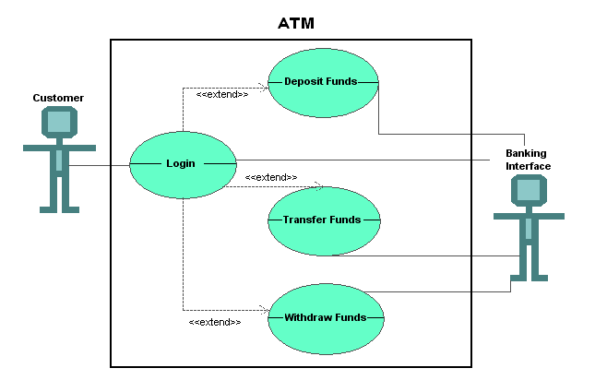
Detailed Descriptions for ATM

Use Case Name
Login to ATM

  - Brief Description
This use case is started by the customer. It provides the capability for the customer to access the customer’s account.

Flow of Events
  - Basic Flow
    - ENTER USERNAME
The use case begins by the system asking for the User ID and password. The customer enters the User ID.

    - ENTER PIN
The customer enters their PIN number.

    - LOGIN TO SYSTEM
The customer presses the LOGIN button. The use case ends

  - Alternative Flow
    - QUIT
The customer can quit any time during the use case. When the customer selects the Quit option, the use case ends.

    - INVALID USER ID / PASSWORD
At LOGIN TO SYSTEM, the system determines if the User ID and/or PIN is not valid. The system displays an error message and the use case ends.

    - CANNOT RETRIEVE INFORMATION
At LOGIN TO SYSTEM or ACCESS SPECIFIC ACCOUNT, the system determines that the system is down, or the specified account is not available. The system displays an error message and the use case ends.

Special Requirements
None

Preconditions
The customer must have approached the ATM system, and already have an existing account.

Post Conditions
None

Extension Points
None

Use Case Name
Transfer Funds

  - Brief Description
This use case is started by the customer. It provides the capability for the customer to transfer funds within a specific account or between two accounts.

Flow of Events
  - Basic Flow
    - TRANSFER FUNDS
The use case begins when the customer selects Transfer Funds.

    - TRANSFER FUNDS WITHIN ACCOUNT
The system displays a list of accounts available to the customer within the user's account. The customer selects the first account from which funds are to be withdrawn, the second account to which the funds are to be deposited, and the amount transferred.

    - FUNDS TRANSFERRED
The system subtracts the amount withdrawn from the first account balance and adds the amount transferred to the second account balance. The system displays a message stating the funds have been successfully transferred and the use case ends.

  - Alternative Flow
    - INVALID FUNDS
At FUNDS TRANSFERRED, the system determines there is not enough money in the first account chosen. The system displays an error message and the use case ends.

    - QUIT
The customer can quit any time during the use case. When the customer selects the Quit option, the use case ends.

    - CANNOT RETRIEVE INFORMATION
At TRANSFER FUNDS WITHIN ACCOUNT, the system determines that the specified service or account is not available. The system displays an error message and the use case ends.

Special Requirements
None

Preconditions
The customer must already be logged in to the system.

Post Conditions
None

Extension Points
None

Use Case Name
Withdraw Funds

  - Brief Description
This use case is started by the customer. It provides the capability for the customer to withdraw funds from any available account of the customer.

Flow of Events
  - Basic Flow
    - WITHDRAW FUNDS
The use case begins when the customer selects Withdraw Funds.

    - WITHDRAW FUNDS WITHIN ACCOUNT
The system displays a list of accounts the customer can withdraw from. The customer selects the account from which funds are to be withdrawn. The customer also selects the amount to be withdrawn.

    - FUNDS WITHDRAWN
The system subtracts the amount withdrawn from the current account balance. The funds are then dispensed and the use case ends.

  - Alternative Flow
    - INVALID FUNDS
At FUNDS WITHDRAWN, the system determines there is not enough money in the account withdrawn. The system displays an error message and the use case ends.

    - QUIT
The customer can quit any time during the use case. When the customer selects the Quit option, the use case ends.

    - CANNOT RETRIEVE INFORMATION
At WITHDRAW FUNDS WITHIN ACCOUNT, the system determines that the specified service or account is not available. The system displays an error message and the use case ends.

Special Requirements
None

Preconditions
The customer must already be logged in to the system.

Post Conditions
None

Extension Points
None

Use Case Name
Deposit Funds

  - Brief Description
This use case is started by the customer. It provides the capability for the customer to deposit funds to any available account of the customer.

Flow of Events
  - Basic Flow
    - DEPOSIT FUNDS
The use case begins when the customer selects Deposit Funds.

    - SELECT ACCOUNT
The system displays the list of accounts available to the customer. The customer selects the account within the specified account from which the funds are to be deposited. The customer also selects the amount to be deposited.

    - FUNDS DEPOSITED
The system adds the amount deposited to the current account balance. The system displays a message stating the funds have been successfully deposited and the use case ends.

  - Alternative Flow
    - QUIT
The customer can quit any time during the use case. When the customer selects the Quit option, the use case ends.

    - CANNOT RETRIEVE INFORMATION
At DEPOSIT FUNDS or SELECT ACCOUNT, the system determines that the specified service or account is not available. The system displays an error message and the use case ends.

Special Requirements
None

Preconditions
The customer must already be logged in to the system.

Post Conditions
None

Extension Points
None

